IPND Support Plan – Addendum for AWS

Housing
The IIS Production environment in AWS comprises virtual machines running Red Hat Enterprise Linux hosted across 2 Availability Zones in the Sydney region.

Availability
The system will be available for transfer of upload files in the prescribed timeframes 99.5% of the time.
The system will be available for transfer of download files in the prescribed timeframes 99.5% of the time.
Upload error and download data files will be created by the prescribed time 99.5% of the time, where the prescribed time is the start of the file transfer window.
System may be available for transfer of upload and download files outside the prescribed timeframes but use of this availability is not covered by this availability requirement.

Redundancy – Infrastructure and Application Failover
In the IPND environment, all application servers have EC2 instances running Red Hat Enterprise Linux (RHEL) 8.4 in an Auto Scaling Group (ASG) spanning 2 availability zones. Each ASG has a minimum and maximum instance count set to 1 so that there is always one server running and fails over seamlessly to the other availability zone in case of one AZ failure.
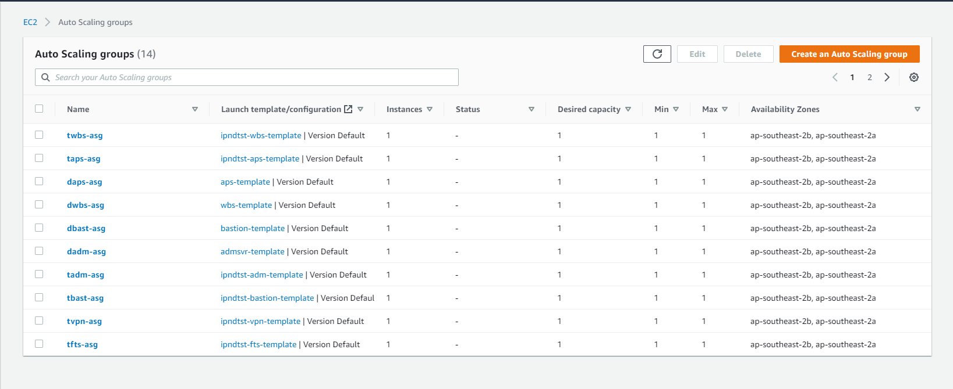
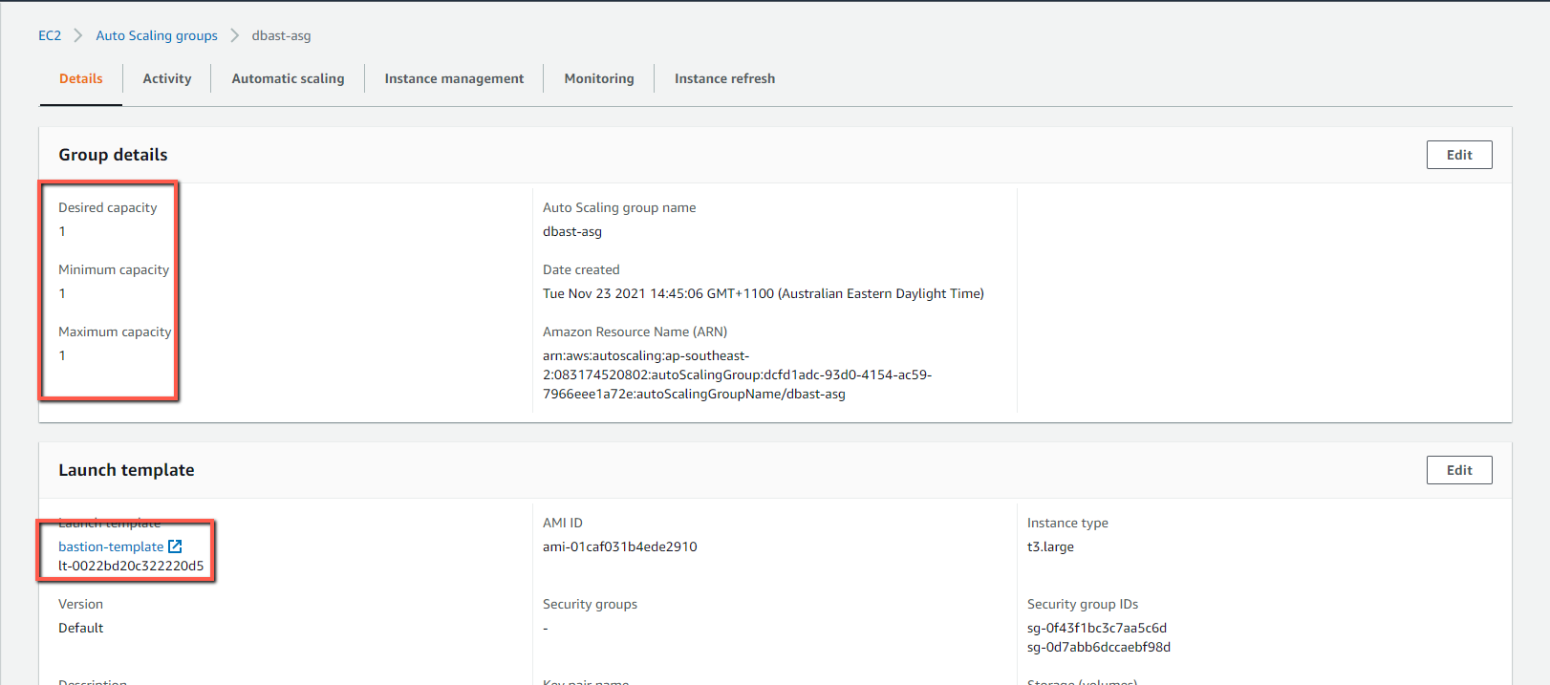

Each virtual server is configured with at least one shared Elastic File System (EFS) storage for persistent data which is attached to the active instance and thus the data is always available to active node.
Before cutting over to the new AWS environment, there will be a period when both environments run in parallel and are active and serving user traffic. During the parallel run, scripts using rsync over ssh run to sync data between the servers. The link between the two environments is provided via two IPSec VPN tunnels. Only differences are sent, any new files are added and any deleted files are deleted on the other environment.

Backup and Restore Procedures
AWS tools are used for automated backups.
The AWS backup console is used to manage AWS backups and provides the ability to restore specific instances.

EC2 Instances and EFS Volumes

Backup
Backups plans consisting of Backup rules define requirements including schedules, retention and lifecycle rules.
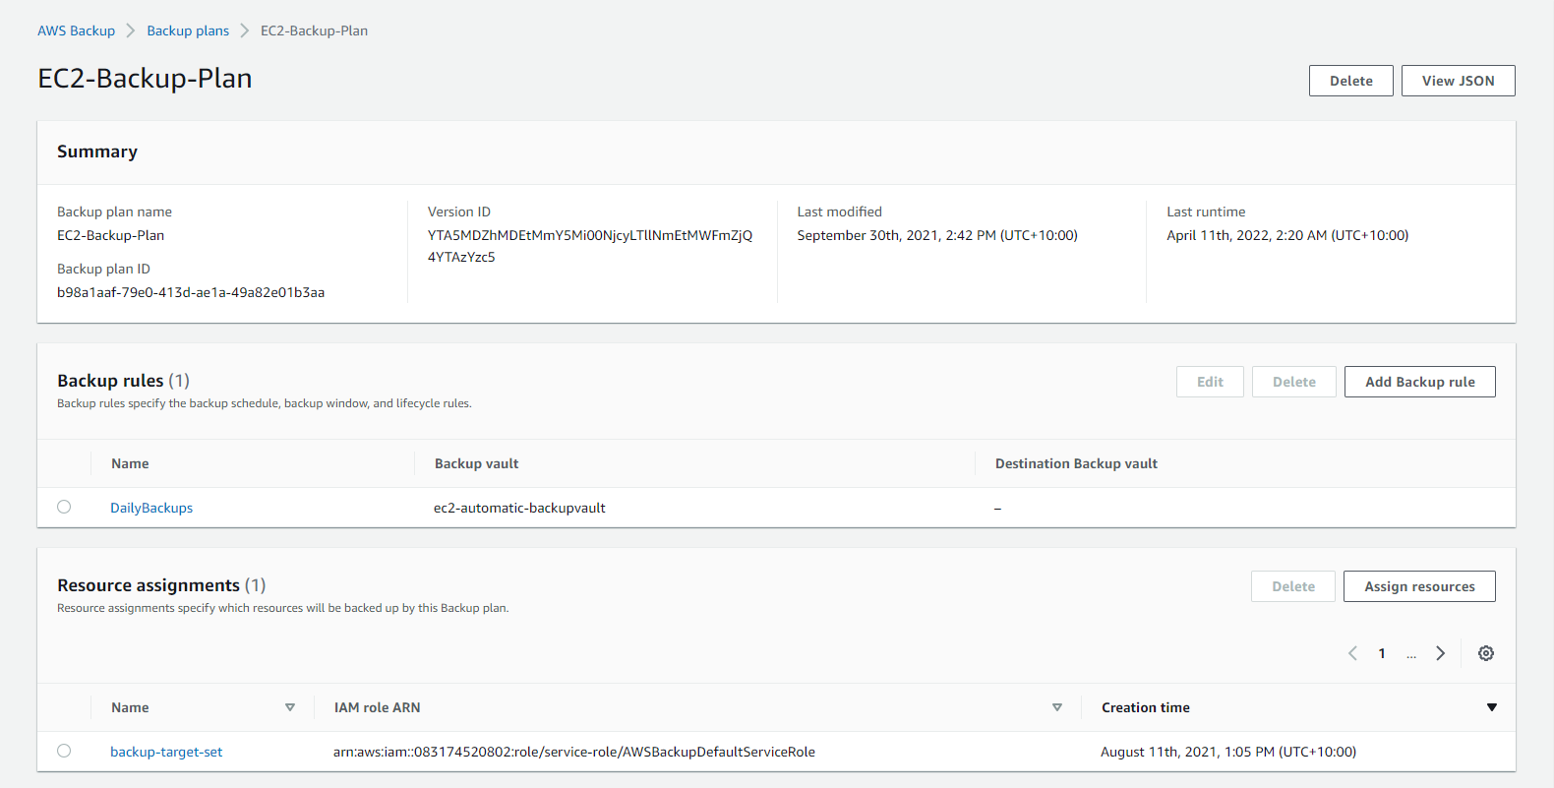

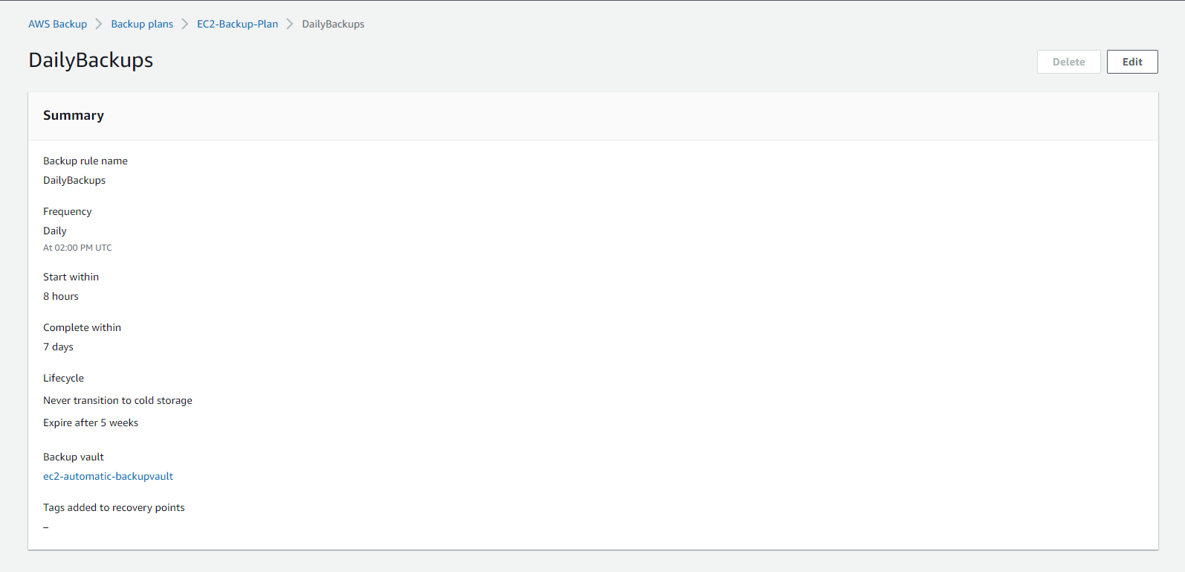
All EC2 instances with a tag of “backup=true” are included in the backup target set. The “backup” tag for all current instances are set in the Launch Templates for the respective auto scaling groups.
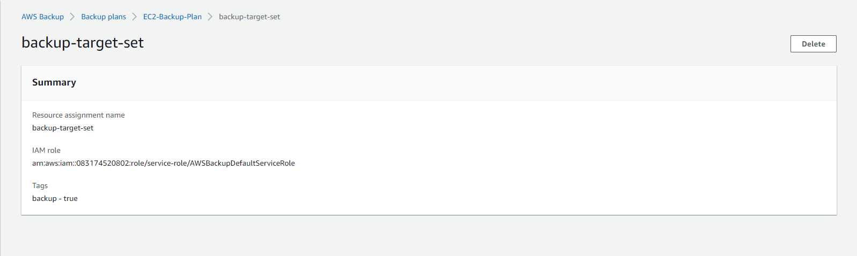
Backups are made available in a Backup Vault once completed.
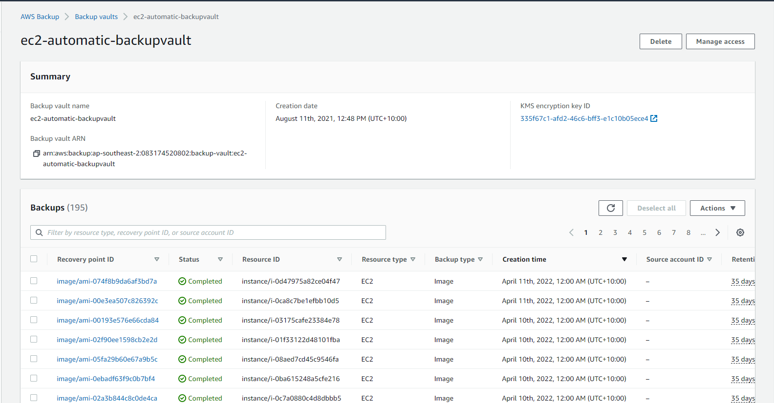

Restore
Specific EC2 instances and EFS volumes can be restored by accessing the instance in the Backup vault via the Backup console.
Restore parameters include options to perform full or item restores and specify restore locations.
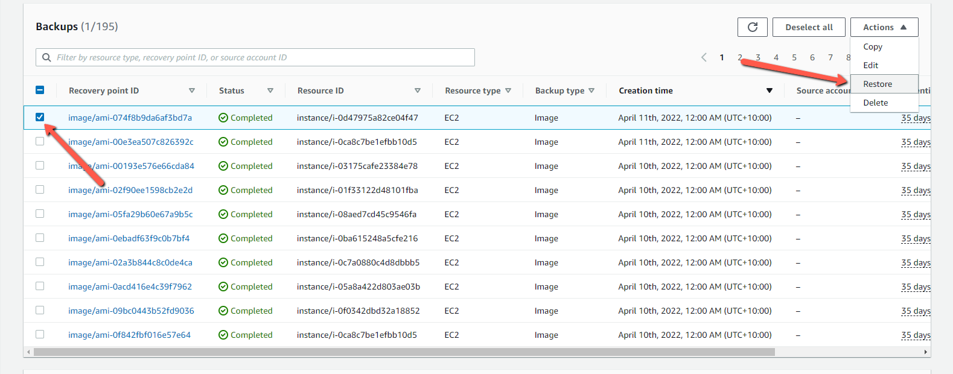

RDS
Database backups are configured via the Amazon RDS Console.

Backup
Amazon RDS creates and saves automated backups of DB instance during the backup window configured for the specific DB instance.
RDS creates a storage volume snapshot of the DB instance, backing up the entire DB instance and not just individual databases.
RDS saves the automated backups of the DB instance according to the backup retention period that has been defined as follows:
Non-Prod: 7 days
Prod: 30 days
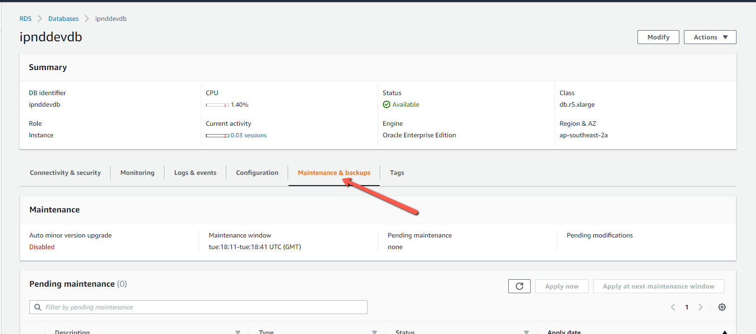
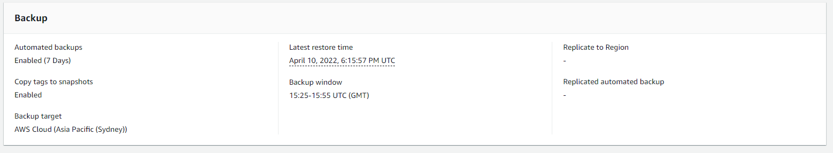

Restore
Snapshot instances are accessible via the Amazon RDS console.
A specific snapshot can be restored when its Status is Available.
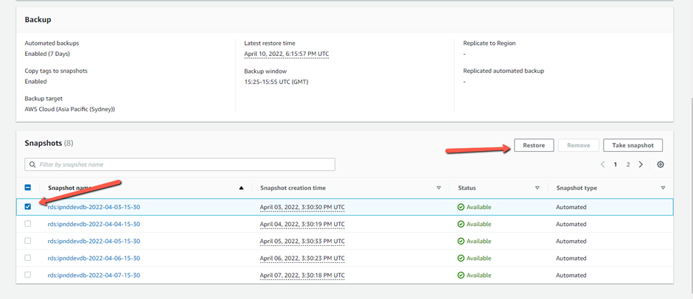

Backup plan details
File Systems | Automated | Frequency | Retention | Lifecycle
EBS (AMI) | Yes | Daily | 5 weeks
EFS (HA/IPND Data) | Yes | Daily | 5 Weeks
S3 (Archive-IPND Data, logs) | Yes | Daily | Transitioned to Cold storage | Indefinite
RDS | Yes | Daily | 5 Weeks

Hardware Specifications

EC2 Instances
Name | Instance ID (Not Persistent) | Instance type | Storage
padm | i-0fc3ad3544591ec81 | t3.large | 60GB + EFS
pvpn | i-058df0a854247642f | t3.large | 60GB + EFS
pbast | i-07dbbcd8757733edd | t3.large | 60GB + EFS
pfts | i-0198f1798fbbfe3e2 | t3.large | 60GB + EFS
ufts | i-020531e5357c070c6 | t3.large | 60GB + EFS
paps | i-045a0ccfe978533b7 | t3.large | 60GB + EFS
uwbs | i-08d2c389ce968b7f6 | t3.medium | 60GB + EFS
ucore | i-07dbbcd8757733edd | t3.large | 60GB + EFS
pcore | i-0198f1798fbbfe3e2 | t3.xlarge | 60GB + EFS
uaps | i-020531e5357c070c6 | t3.medium | 60GB + EFS
pwbs | i-0fdafac565c8c126a | t3.large | 60GB + EFS
wazuh | i-031a756d3fb333b1c | t3.medium | 60GB + EFS

RDS
DB identifier | Engine | Region & AZ | Size | Multi-AZ
iisdbonboarding | MariaDB | ap-southeast-2a | db.r5.large | Yes
iisdbprod | MariaDB | ap-southeast-2b | db.r5.xlarge | Yes
ipndonboarding | Oracle EE | ap-southeast-2b | db.r5.large | Yes
ipndprod | Oracle EE | ap-southeast-2b | db.r5.xlarge | Yes
ipndonboarding-dg | Oracle EE | ap-southeast-2b | db.r5.large | N

Note: ipndonboarding-dg is temporary for dataguard. Can be deleted after the migration or retained and replicated against production DB for reporting purposes (additional usage cost).

IPSec VPN Tunnels

Customer Gateways
Name | ID | Type | IP Address
ipndprod-legacy-cgw | cgw-09fa35be73958e119 | ipsec.1 | 165.228.102.90
ipndarp-legacy-cgw | cgw-010186ac779187aa8 | ipsec.1 | 165.228.105.138

VPN Gateway
Name | ID | Type
ipndprod-legacy-vgw | vgw-091d3001f461dde24 | ipsec.1

IPSec Tunnels
Name | Virtual Private Gateway | Customer Gateway | Local IPv4 NetworkCidr | Remote IPv4 NetworkCidr
ipndarp-legacy-bridge | vgw-091d3001f461dde24 | ipndprod-legacy-vgw | cgw-010186ac779187aa8 | ipndarp-legacy-cgw | 10.0.8.0/21 | 10.12.0.0/16
ipndprod-legacy-bridge | vgw-091d3001f461dde24 | ipndprod-legacy-vgw | cgw-09fa35be73958e119 | ipndprod-legacy-cgw | 10.0.8.0/21 | 10.12.0.0/16

OpsVPN – Server and Ops User certificates.

Server Cert – Existing
Current OpsVPN Serve Certificate is available in Secrets Manager
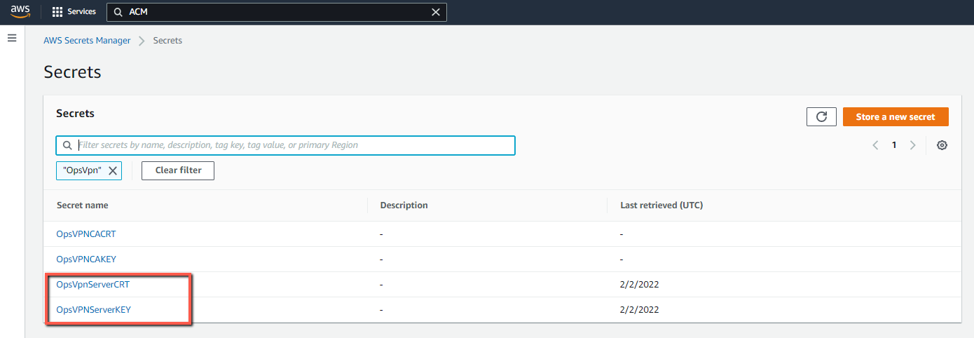

Server Cert - Renewal

CA Cert
- Follow https://community.openvpn.net/openvpn/wiki/EasyRSA3-OpenVPN-Howto to setup CA on the ADM server
- Replace the generated CA Cert and Key in the above step with the ones in Prod Secrets Manager before generating any Server or Client certificates
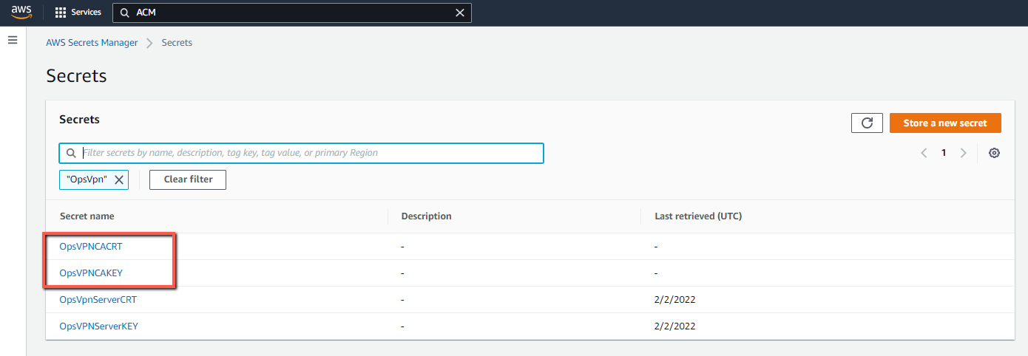

Server Cert
- Generate new Server cert in Easy RSA 3 using the above CA following https://community.openvpn.net/openvpn/wiki/EasyRSA3-OpenVPN-Howto
- Import (Reimport) the certificate to AWS ACM
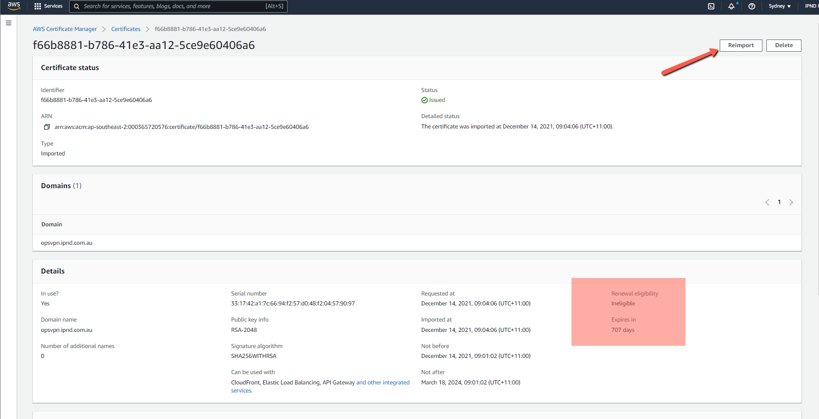
- Create and distribute Ops user certificates using the process at https://community.openvpn.net/openvpn/wiki/EasyRSA3-OpenVPN-Howto

SimpleAD Cert Renewal
Current cert is available in Secrets Manager
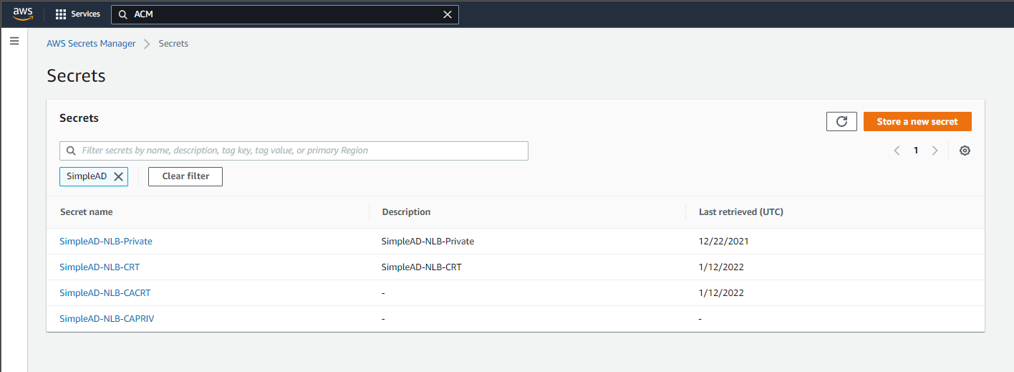
For renewal:
- Follow the Same process as OpsVPN Server Cert.
- Generate the Server Certificate and import (reimport) into AWS Cert Manager
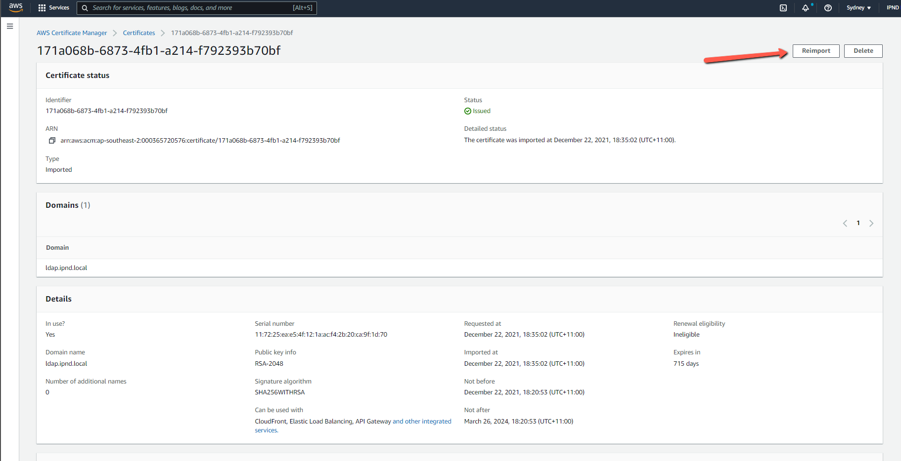

Ovpn Cert
The gw1.ipnd.com.au SSL certificate is issued and maintained on the AWS VPN servers using acme.sh automation

SSSD_Obfuscate
In case the LDAP (Simple AD) password is changed, or a new EC2 instance needs to talk to the LDAP, the applicable LDAP password needs to be encoded in the sssd_conf using sssd_obfuscate

Audit log rotation
Following changes are applied to IIS Prod servers for audit log rotation. This will require to be checked and implemented on other prod servers in order to prevent audit log volume filling up and making the instance unresponsive and eventually ASG instance refresh terminating the existing instance.
changes:
/etc/audit/auditd.conf :
max_log_file_action = ignore

/etc/audit/rules.d/audit.rules added:
-a never,exclude -F msgtype=CWD
-a never,exclude -F msgtype=PROCTITLE

Appended following to all rules in /etc/audit/rules.d/50-time_change.rules:
-F subj_type!=chronyd_t

/etc/cron.daily created auditd.cron
#!/bin/bash
export PATH=/sbin:/bin:/usr/sbin:/usr/bin

FORMAT="%F_%T" # Customize timestamp format as desired, per `man date`
# %F_%T will lead to files like: audit.log.2015-02-26_15:43:46
COMPRESS=gzip # Change to bzip2 or xz as desired
KEEP=90 # Number of compressed log files to keep
ROTATE_TIME=5 # Amount of time in seconds to wait for auditd to rotate its logs. Adjust this as necessary

rename_and_compress_old_logs() {
# Keep uncompressed for last 24 hours
for file in $(find /var/log/audit/ -name 'audit.log.[2][5-9]'); do
timestamp=$(ls -l --time-style="+${FORMAT}" ${file} | awk '{print $6}')
newfile=${file%.[2][5-9]}.${timestamp}
# Optional: remove "-v" verbose flag from next 2 lines to hide output
mv -v ${file} ${newfile}
${COMPRESS} -v ${newfile}
done
for file in $(find /var/log/audit/ -name 'audit.log.[3-9][0-9]'); do
timestamp=$(ls -l --time-style="+${FORMAT}" ${file} | awk '{print $6}')
newfile=${file%.[3-9][0-9]}.${timestamp}
# Optional: remove "-v" verbose flag from next 2 lines to hide output
mv -v ${file} ${newfile}
${COMPRESS} -v ${newfile}
done
for file in $(find /var/log/audit/ -name 'audit.log.[1-9][0-9][0-9]'); do
timestamp=$(ls -l --time-style="+${FORMAT}" ${file} | awk '{print $6}')
newfile=${file%.[1-9][0-9][0-9]}.${timestamp}
# Optional: remove "-v" verbose flag from next 2 lines to hide output
mv -v ${file} ${newfile}
${COMPRESS} -v ${newfile}
done
}

delete_old_compressed_logs() {
# Optional: remove "-v" verbose flag to hide output
/bin/rm -f -v $(find /var/log/audit/ -regextype posix-extended -regex '.*audit\.log\..*(xz|gz|bz2)$' | sort -n | head -n -${KEEP})
}

rename_and_compress_old_logs
service auditd rotate
sleep $ROTATE_TIME
rename_and_compress_old_logs
delete_old_compressed_logs

Wazuh setup:
https://documentation.wazuh.com/current/installation-guide/
Wazuh instance in Prod: 10.12.20.80
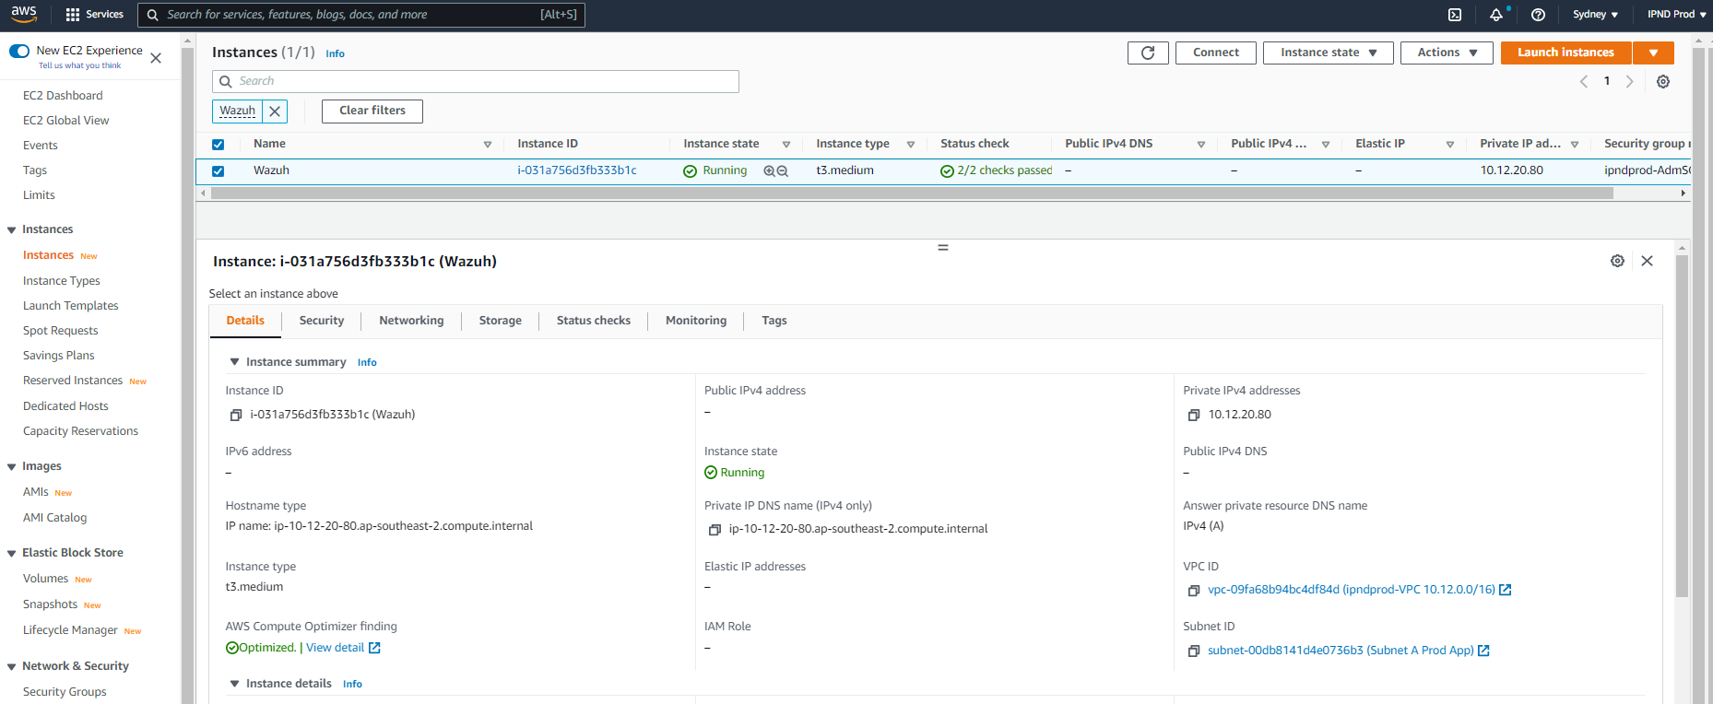
Connect using SSH tunnel via pbast:
ssh -L 443: 10.12.20.80:443 pbast2 -p 22220
Following passwords were generated during installation, main one for use being “wazuh” user for the GUI access via the above ssh tunnel:
The password for wazuh is OdqZSYlTSmEMBDwAgYa6iYzoRO-22lHc
The password for admin is cGO3AsP_n91ZyUvNf2rr8YkVw0L4cE6u
The password for kibanaserver is -Ii5evCwPAgtBjegu69LbfLwCTLQMPJF
The password for kibanaro is 5A0HjuSJGiUUiUtmBx0wEBIm0Ydex3tn
The password for logstash is gIB-PWrk2UVX2Hjm174DEDlmjfhrB_Zj
The password for readall is bZ-GBfOsd_S_cPR3FoImORQQSlcGUkoF
The password for snapshotrestore is mRINxaa8r1-9kzcAnGjxH0M01CWOmmHQ
The password for wazuh_admin is BLUGrfbwsA83sM2v14laxmttop5DAO6X
The password for wazuh_user is 3EVTrIdWxfYipQCDBU7upx8gqY_yZUV2

Patching
All EC2 instances will be patched according to current IPND patch management process and AWS guidelines defined at https://docs.rackspace.com/docs/fanatical-support-aws/patching/amazon-ec2:
Normal Flow
- Each live Development Instance is patched, rebooted and tested.
- If there are issues with the patched version the instance is terminated and a new instance is started from an un-patched AMI (Amazon Machine image)
- If the patch and subsequent checks are successful, then the development AMI image migrated to the test environment, where it is tested
- If there are no issues with the patched version the Test instance, then the updated AMI is migrated to UserTest(Onboarding) environment and 2 weeks later to Production environment.
- The time delay between an updated AMI to the next environments is approximately 2hrs
- We retain the last 3 original environment AMI images.

BuildServer
The build server instance in Non-Prod environment has all the build environment for compiling ipnd-ufm and ipnd-core code. Sudo as ipndapp user which has all the build environment configured.
You can pull code from the CodeCommit repositories ( https://ap-southeast-2.console.aws.amazon.com/codesuite/codecommit/repositories?region=ap-southeast-2 ) and initiate compile.

This server was supposed to be part of the CI/CD pipeline I was working on to automate code build, test and deploy to other env based on “git push” to the repo. Unfortunately this activity could not be completed in time. So this server may be useful of someone wants to pick up and implement the CI/CD pipeline
